**ACTIVITY 4**

* Open index.html on **Chrome**

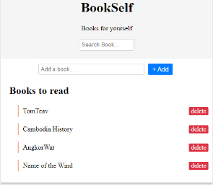

* Open VSCode and edit script.js
* Follow the steps below, and **submit your script to google classroom**

**Now** it is finally time to make this web page **fully** **functional**!!

**Q1 -**  Add an Event to delete the book when clicking on “delete”

**Q2 -**  Add an Event to add a new book with correct title when clicking on the “+Add” button (Be careful of the type of button it is !)

**Q3 -**  Add an Event to make the “Search Book…” bar working.

Hint : you can Hide/Show elements of the list if their title match or don’t match the Search Book field value.